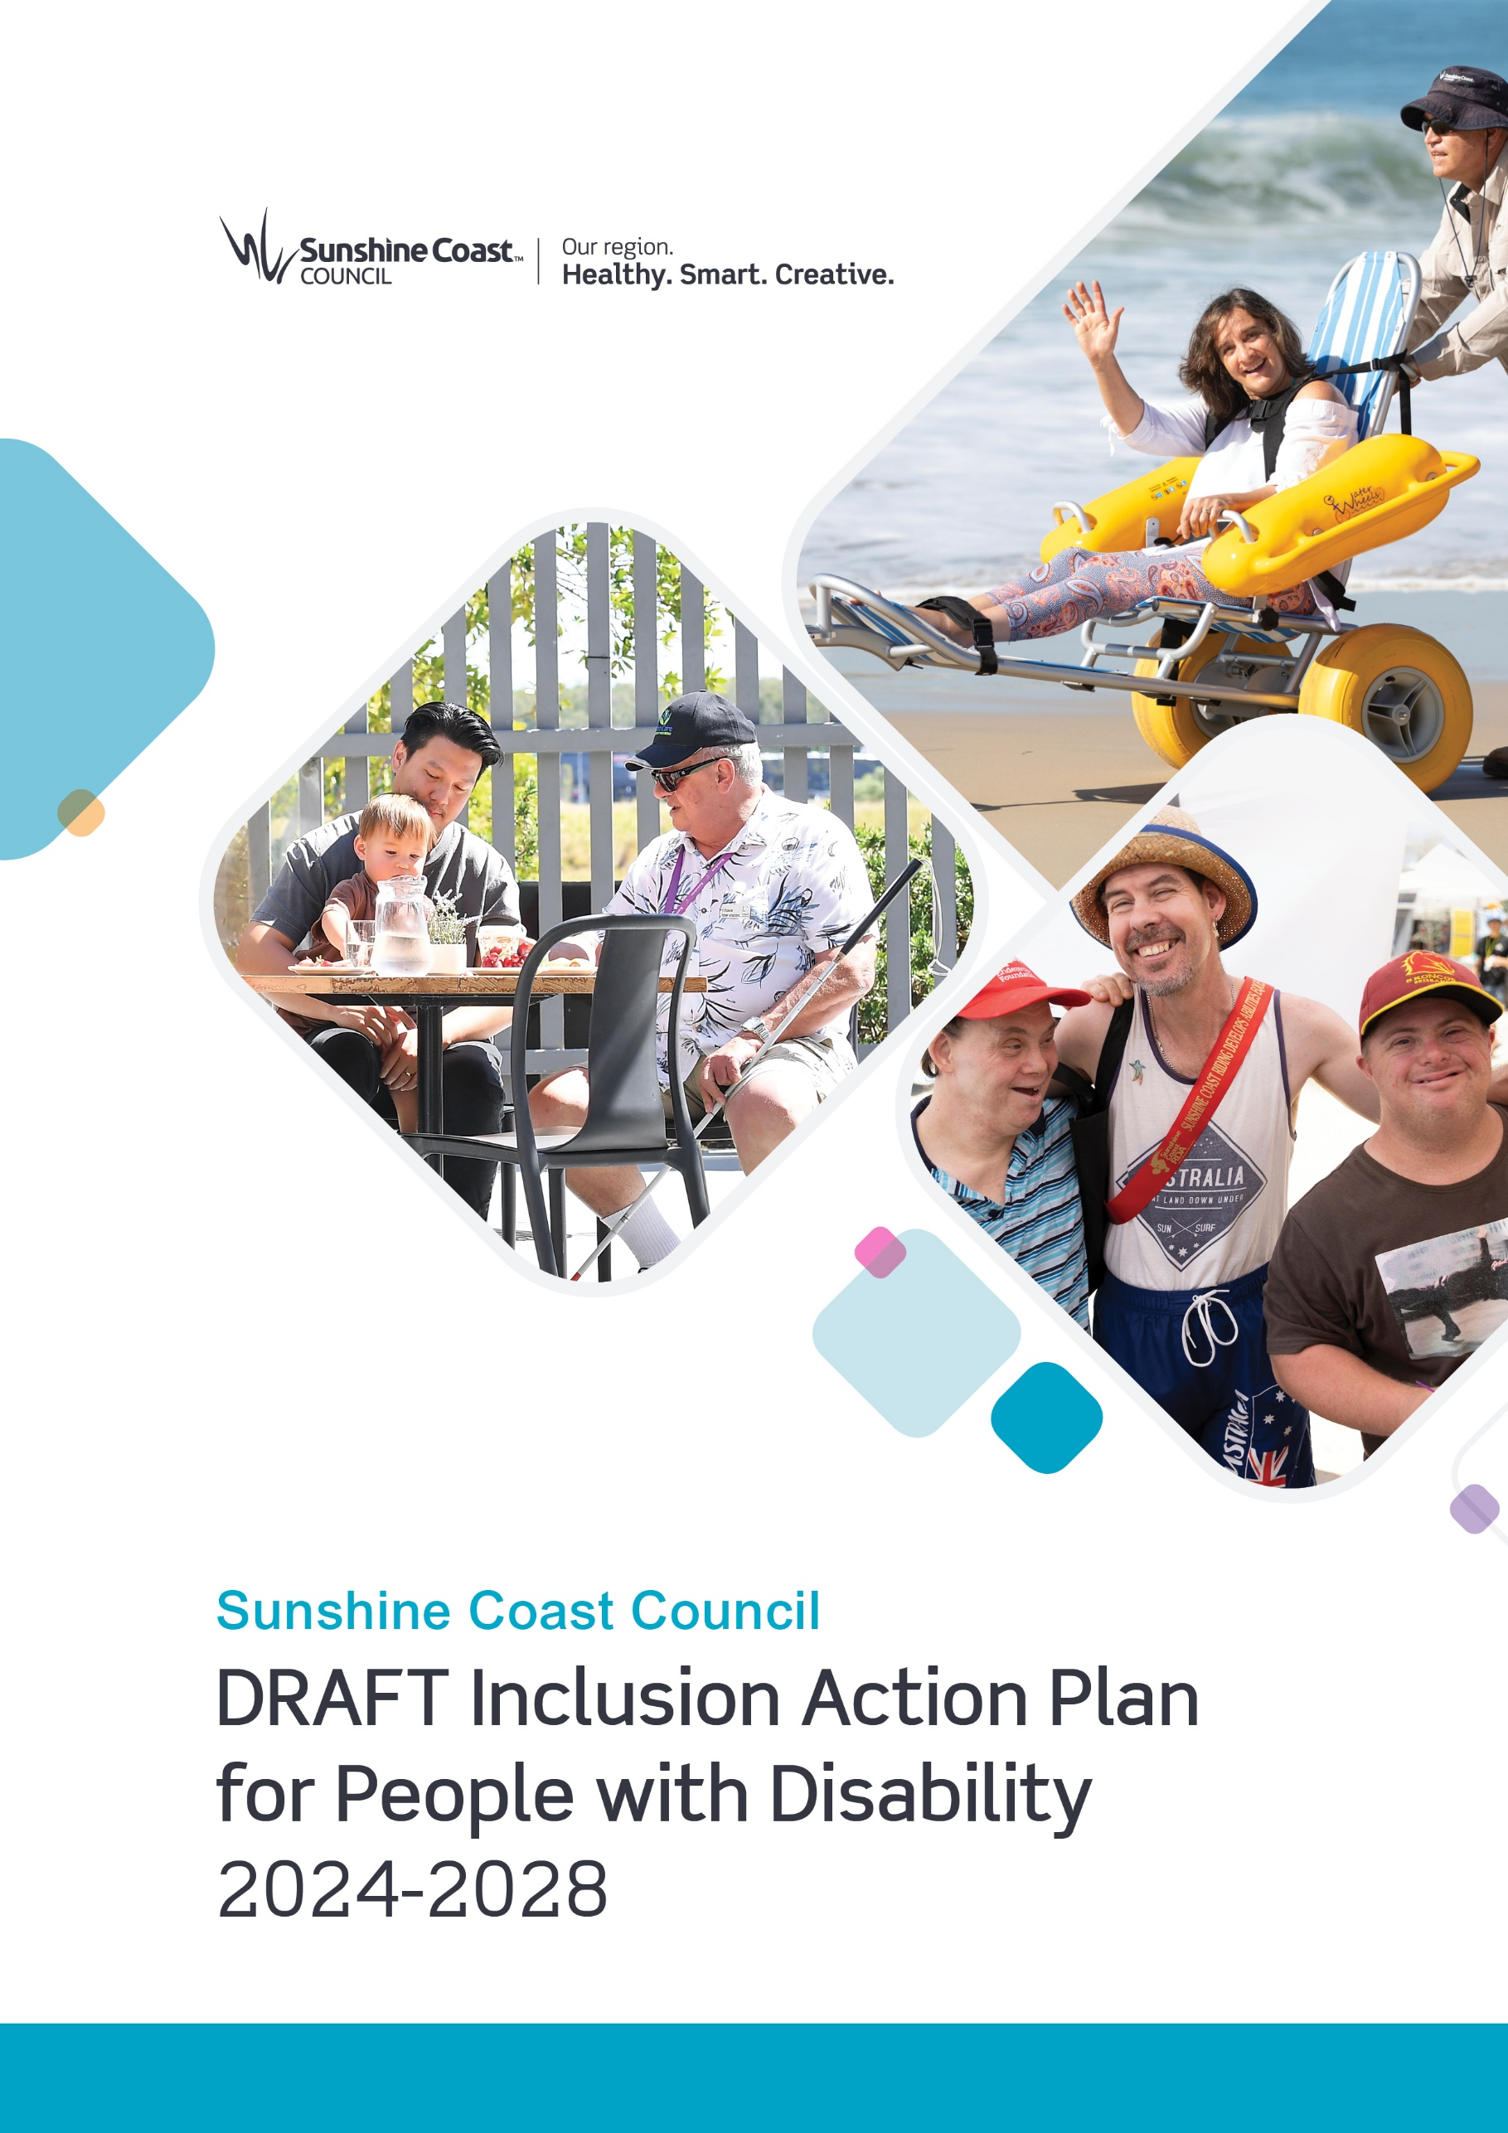

Information Sheets

Information Sheet 1:

What is Disability?
A disability is a long-term physical, mental, intellectual or sensory impairment which, in interaction with various barriers, may hinder full and effective participation in society.
In Australia, 1 in 6 people have disability. It is likely that almost everyone will experience disability at one point or another in their lives, for some people this will be temporary, while for others, it will be permanent.
Disability is diverse. Different types of disabilities include:
- Physical: affecting a person’s mobility, physical capacity, stamina, and balance
- Intellectual: affecting a person’s ability to learn, communicate and process information
- Sensory: affecting a person’s senses including deafness and hearing loss, blindness and low vision
- Neurological: affecting a person’s brain and nervous system
- Cognitive: affecting a person’s thought processing, attention, and memory
- Psychiatric: affecting a person’s thinking, emotions, and behaviour.
A person may have multiple disabilities. Having a disability may or may not be a significant part of a person’s identity. A person with disability may have other identities impacting their experience of life.

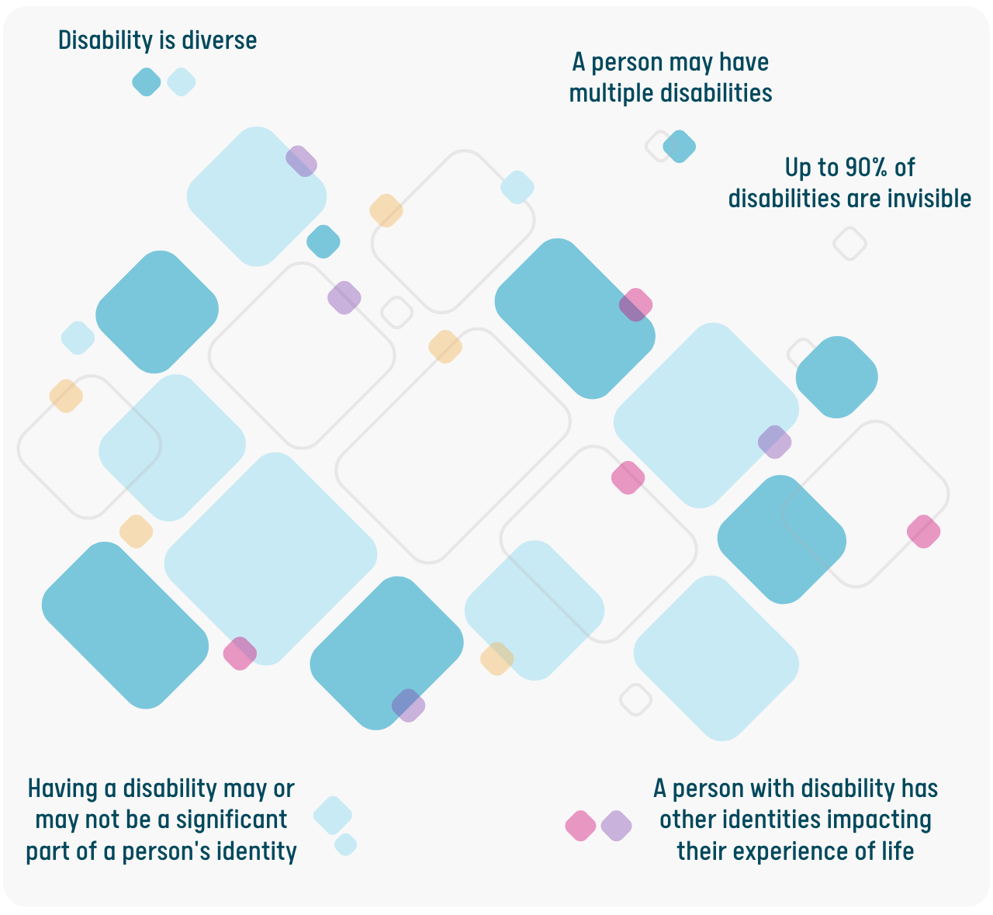

Invisible Disability
A disability that is not immediately visible to others is sometimes referred to as an “invisible disability”. Autism, ADHD, chronic pain, diabetes, epilepsy and mental illnesses such as depression and anxiety disorders, are examples of invisible disabilities that may not always be visible to others. Some estimates suggest that up to 90% of people with disability have an invisible disability.

Snapshot of People with Disability in Australia
4.4 million residents of Australia (18% of population) had a disability in 2018. This includes 1.4 million people (5.7% of population) with a severe or profound disability (32% of people with disability).
Australian Bureau of Statistics data suggests that of the 4.4 million people with disability in Australia in 2018:
- 77% (3 in 4) had a physical disability as their main disability. This included:
- Musculoskeletal system and connective tissues (30%), such as back pain and arthritis
- Ear and mastoid process (8.4%), such as hearing loss and tinnitus
- Circulatory system (6.3%), such as heart disease and stroke
- Nervous system (6.7%) such as cerebral palsy and multiple sclerosis.
- 23% (1 in 4) had a mental or behavioural disability as their main disability. This included:
- Intellectual and developmental (6.5%), such as intellectual disability and autism
- Mood affective (3.8%) such as depression
- Dementia and Alzheimer’s disease (2.6%).
Only around 4.4% of people with disability used a wheelchair (across Australia in 2015).
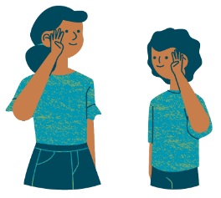 | 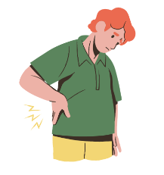 | 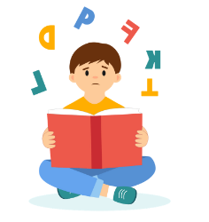 | 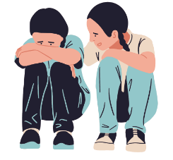
1.1 million Australians  are affected by hearing loss | 1.5 million Australians  with chronic or recurring pain or discomfort | 0.7 million Australians  experience difficulty learning or understanding things | 0.5 million Australians  with mental illness
1 in 6 people aged 15-64 years with disability experienced discrimination based on their disability in the previous year and 4 in 9 people avoided situations because of their disability.
In 2017-18, people with disability compared to people without disability, were more likely to report: an insufficient level of physical activity in the last week, being overweight or obese, and eating insufficient serves of fruit and vegetables per day.

Snapshot of People with Severe Disability in the Sunshine Coast
- 21,211 residents of the Sunshine Coast had a severe disability requiring assistance (6.2% of residents). This was a higher rate of disability than for South East Queensland (5.7%) – but this is due to the older age profile of the Sunshine Coast. The number of residents with a severe disability has more than doubled in the last 15 years, from 9,728 people in 2006 to 21,211 people in 2021.
- 3,171 residents of the Sunshine Coast had dementia in 2021 (or 0.9% of the total population). Around 80% of these residents with dementia had a severe disability and 44% lived in non-private dwellings, such as residential aged care.
- 33,328 residents of the Sunshine Coast provided unpaid assistance to a person with disability, health condition or due to old age during a two-week period (or 11.8% of the total population).
Rates of severe disability were higher for:
- Older people – with 16% of the population 65 years of age and older having a severe disability compared to 6.2% for the total population.
- First Nations people – with 9.0% of Aboriginal and/or Torres Strait Islander people having a severe disability compared to 6.2% for the total population. This is despite the First Nations population being significantly younger (median age of 23 years compared to 43 years for the total population).
Rates of severe disability were lower for:
- Residents born overseas – with 4.9% of residents born overseas having a severe disability compared to 6.2% for the total population. This is partially because overseas born residents are more likely to be younger and therefore in age groups with lower prevalence of disability.
Of residents with a severe disability:
- 1,333 people aged 15-64 years were employed – this equates to 20% of those 15-64 years which is significantly lower than for those without a disability at 79%. This includes 340 people with a severe disability who worked full-time.
- 1,328 people aged 15-64 years had completed tertiary education (diploma or higher) – this equates to 20% of those 15-64 years which is significantly lower than for those without a disability at 38%.
- 3,377 people were living alone – this equates to 18% of those with a severe disability which is significantly higher than for those without a disability at 9%.
All data in this section is based on 2021 Census data.

Information Sheet 2:

Concepts and Principles

Social model of disability
The social model of disability recognises that people are ‘disabled’ because of barriers they experience living with impairments in society, rather than by the disability itself. Different types of barriers include attitudinal, environmental, organisational and communication barriers. It is through removing barriers in society, that people with disability are able to participate fully and equally.
Examples of types of barriers include:
- Attitudinal barriers: For example, not being aware of some of the different types of disabilities are can lead people to judge or make assumptions about people with disability.
- Environmental barriers: For example, not offering guests of a live-music event the opportunity to have some quiet time in a ‘quiet space’ can lead to some people experiencing sensory overload in a live-music event.
- Organisational barriers: For example, failing to provide workplace adjustments to people with disability can result in some people being unable to fulfill the requirements of the role even though they may have the relevant skills or qualifications.
Communication barriers: For example, not providing alternative formats to written communications, such as an easy-read or large print version, can affect people who experience vision or cognitive difficulties from accessing information.

Language choice
A person-first language approach chooses to put the person before their disability – for example, a ‘person with disability’. While an identity-first language approach puts a person’s disability before the person – for example ‘disabled person’.
The Inclusion Action Plan for People with Disability uses a person-first language approach. Sunshine Coast Council acknowledges that the preferred language of disability varies between individuals and groups and preferred language may change in the future. Council does not want to exclude anyone based on the language approach used. We endeavour to work with and continue to learn from people with lived experience of disability to ensure language choice is respectful.

Lived experience
Lived experience belongs to people with a direct, first-hand experience of a particular topic or situation, rather than gained through research. Involving people with lived experience directly in action plan development ensures that the perspectives, needs and insights of people with direct experience are valued and understood.

Human rights
Human rights recognise the inherent value of each person, regardless of background, where we live, what we look like, what we think or what we believe. They are based on principles of dignity, equality, and mutual respect, which are shared across cultures, religions and philosophies. They are about being treated fairly, treating others fairly and having the ability to make genuine choices in our daily lives.

Social justice
Social justice refers to a political and philosophical theory that focuses on the concept of fairness in relations between individuals in society and equal access to wealth, opportunities, and social privileges in a society. The five main principles of social justice include access to resources, equity, participation, diversity, and human rights.

Access
Regardless of individual circumstances, characteristics, disabilities, culture or background all members of the community will have equitable opportunity to access and utilise information, services, facilities and places.

Equity
Equity implies that an individual may need to experience or receive something different (not equal) to maintain fairness and access.

Inclusion
A socially inclusive society is defined as one where all people feel valued, their differences are respected, and their basic needs are met so they can live in dignity. Social exclusion is the process of being shut out from the social, economic, political, and cultural systems which contribute to the integration of a person into the community.

Intersectionality
Intersectionality refers to the many ways that different personal characteristics or elements of personal identity expose people to overlapping forms of discrimination and marginalisation and may be based on age, ability, ethnicity, gender or sexual orientation.
Some people with disability are more vulnerable to discrimination due to a combination of personal characteristics, such as people with disability who are also women, First Nations people, LGBTQIA+, culturally diverse, and/or recent migrants.

Universal design
Universal design is the design of buildings, the built environment and information so that it is accessible to all people. The universal design principles recognise human rights that are afforded to everyone regardless of their age, ability or cultural background.
The 7 principles of universal design are:
- Principle 1: Equitable use – for everyone
- Principle 2: Flexibility in use – adaptable to meet the needs of everyone
- Principle 3: Simple and intuitive use – easy to understand and use
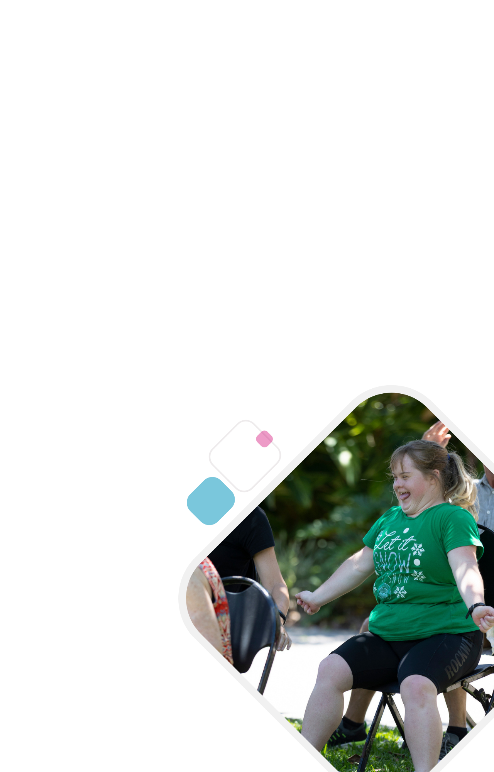
- Principle 4: Perceptible information – information is clear and able to be understood
- Principle 5: Tolerance for error – easy for everyone to use when error strikes
- Principle 6: Low physical effort – easy for everyone to use
- Principle 7: Size and space for approach and use – useable by everyone regardless of size or mobility

Co-design
Co-design is a participatory process which involves working with others to share ideas and design solutions. Co-design allows everyone to contribute to discussion equally and develop common goals and objectives. A co-design process offers opportunity for collaboration between council and the community.

Information Sheet 3:

Our Engagement Process

Engagement Undertaken
Council undertook an inclusive engagement process to develop the draft Inclusion Action Plan for People with Disability.

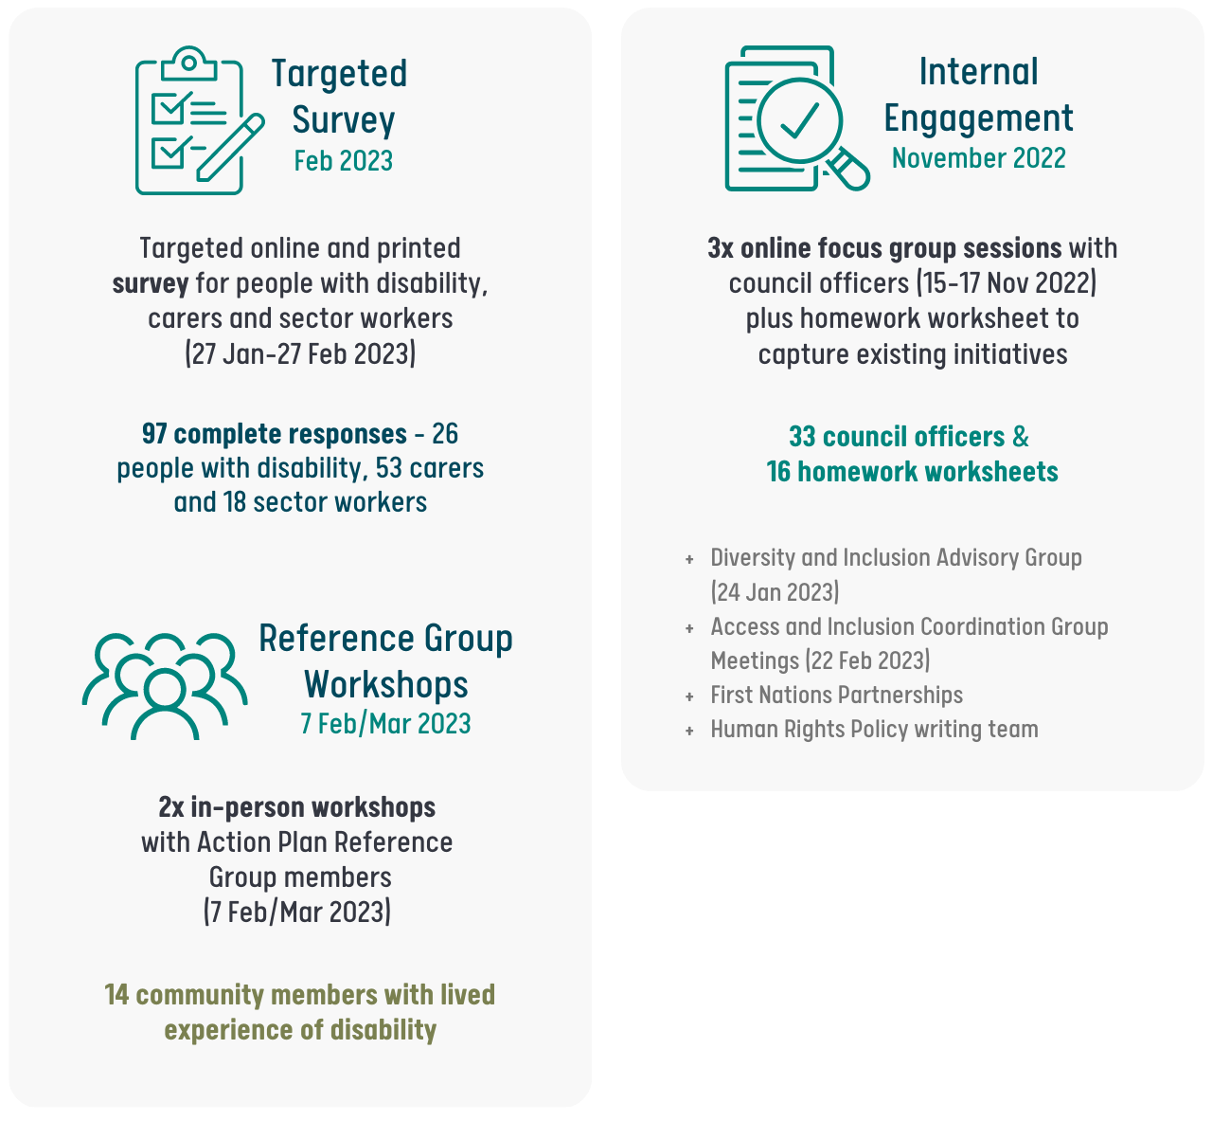

Engagement undertaken for the project included:
- Targeted surveys for people with disability, carers and disability sector workers from 30 January to 27 February 2023. The surveys were completed by 97 respondents.
- The 97 respondents included 26 people with disability, 53 carers and 18 disability sector workers
- 3 First Nations people, 7 LGBTQIA+ people, and 1 person who spoke a language other than English at home completed a survey.
- Two in-person workshops with the Action Plan Reference Group (7 February and 7 March 2023):
- 14 members of the community with lived experience of disability volunteered to be part of the group to guide development of the action plan
- Members included people with diverse disabilities, carers and representatives from organisations and advocacy groups
- The group had a mix of young people and older people, and a balanced gender mix.
Three online council focus groups attended by 33 council team members, with 16 pre-homework worksheets completed in November 2022 (15-17 November 2022).
Engagement also included:
- Two in-person workshops with the Access and Inclusion Coordination Group made up of internal and external stakeholders (including staff and community with lived experience of disability)
A meeting with council’s First Nations Partnerships Team (January 2023) and two meetings (one in-person and one online) with council’s Diversity and Inclusion Advisory Group (January and March 2023).

What you told us?

Targeted Survey
People with disability, carers and disability sector workers identified the following priority areas to improve inclusion:
- Discrimination and exclusion to be addressed through awareness and education
“People with disabilities don’t have special needs they require additional supports so they can navigate their community as easily as possible.”
- Transport and parking
- Appropriate and affordable housing and tourist accommodation
- Employment and training opportunities
- Involvement in decision making
- Improvements to public spaces
- Accessibility and availability of information
- Access to nature
- More investment needed to make change
- Ability to participate in chosen activities.
The following principles were also communicated by survey participants through open-ended responses across the survey:
- Involve people with disability in decision making
- Disability cannot be thought of as being the same for everyone – there is great diversity in disability, including invisible disability
- Community awareness and education are fundamental to opening opportunities and reducing discrimination
- All activities should be accessible, rather than having separate activities for people with disability
- People with disability need extra support to participate
- Recognise the value of people with disability in work and the community
Need to implement change, not just talk. Focus on most important actions and follow through.
The following sections provide a summary of the responses from the survey:

Top challenges for people with disability living on the Sunshine Coast:
- Discrimination in daily life (82% of respondents)
- Difficulty getting around (72% of respondents)
- Access to suitable and affordable housing (68% of respondents)
- Job opportunities (62% of respondents)
- Having a say on important community issues (59% of respondents)
Difficulty participating in chosen activities (52% of respondents).

Top positives for people with disability living on the Sunshine Coast:
- There are good service providers (68% of respondents)
- People are accepting of people with disability (48% of respondents)
Can get out in the natural environment (41% of respondents).

If you could change one thing to make it easier to participate in community life, what would it be?
Summary of open-ended responses:
- Public realm improvements: Public toilets, footpaths, open space, buildings, playgrounds
- Transport and parking: Public transport, parking, taxis, training for transport workers
- Access to nature: Beach, walking tracks
- Employment and training: Within council and local businesses
- Awareness and education: Diversity of disability, invisible disability, education for children
- Involvement in decision making
More spending: Investment to improve access and inclusion.
Here are some of the contributions to this question directly from respondents to the survey:
- “I think the Sunshine Coast should be a hub that people with a disability want to come to because they feel like they can live the life they want and they will be supported in that.”
- If I could change one thing to make it easier to participate in community life, it would be the “acceptance of the wider community to people with disability”.
- If I could change one thing to make it easier to participate in community life, it would be “that the community stop assuming diminished capacity when the word disability is used”.
- “A greater awareness [is needed that most disabilities are invisible]. The trauma [that people with invisible disability] have to endure going out in public, limits them from wanting to. Awareness removes barriers.”

Top five types of places that should be prioritised to improve accessibility / inclusion:
- Beaches (47 respondents)
- Bushland and natural reserves (33 respondents)
- Pools and leisure centres (24 respondents)
- Town centres (22 respondents)
Playgrounds (18 respondents).

Suggested improvement needed to public spaces:
- Accessible pathways and kerb ramps (50 respondents)
- Disability confident staff (42 respondents)
- Accessible toilets and adult changing (42 respondents)
- Accessible entrances to buildings (42 respondents)
- Beach matting and beach wheelchairs (37 respondents)
Accessible parking (37 respondents).

Information needed to plan an outing:
Summary of open-ended responses:
- Parking and entrance to venue: accessible parking, distance/access from carpark to venue
- Facilities and amenities: accessible toilets, seating and rest areas, air conditioning
- Safety and security: safe and secure, safety for children
- Staff awareness and acceptance: availability of staff, acceptance
- Transport: availability and accessibility of transport, accommodation for service animals, ease of finding and accessing venue
Crowds and noise: availability of quiet zones or spaces, ways of minimising noise and crowds.

Suggested improvement needed to local businesses:
- Staff trained in disability awareness and inclusive practices (67 respondents)
- Providing accessible toilet facilities (55 respondents)
- More accessible parking spaces (49 respondents)
- Installing ramps and fitting handrails (46 respondents)
- Having suitable counter heights for people who use a wheelchair (46 respondents)
Low sensory shopping times (45 respondents).

Employment challenges for people with disability:
- Lack of available jobs (38 respondents)
“The general public needs to know more about what a person with disability is capable of. Providing more information to businesses around customised employment and accommodations. Helping people start to think about a new way of thinking about employment.”
- Discriminatory attitudes and behaviours (37 respondents)
- Lack of assistance or support (34 respondents)
- Difficulty accessing flexible work arrangements (30 respondents)
Lack of available accessible transport (27 respondents).

Suggested improvement needed to council information:
- Accessible layouts (45 respondents)
- Large print (39 respondents)
- Easy English version (37 respondents)
- Image descriptions (35 respondents)
- Video with captions (33 respondents)
Audio format (33 respondents).

Suggested improvements to council interactions:
Summary of open-ended responses:
- Disability aware and confident staff: more approachable, treat people with care and respect, treat people as individuals.
- Dedicated disability liaison on council staff: dedicated staff member to advocate and address issues, one person to contact, easy contact details.
- Accessibility: parking, audio loops, meet online.
- Outreach and communication: surveys, focus groups, direct mail, open forum, distribute materials through disability services, regular monthly meeting online, open day at council.
- Website improvements: remove moving graphics from website, clearer, logical flow.
Note: Comments were before website upgrade on 1 March 2023 which may have improved functionality.

What do you enjoy about council programs and events:
Summary of open-ended responses:
- Trying new activities and experiences
- Easy to access
- Range of activities available
- Socialising, connection and companionship
- Feeling accepted and included
- Feeling safe and comfortable
- Learning new skills
- Relaxed / quiet settings
- Participating in community
- Fun
Low cost.
Here are some of the contributions to this question directly from respondents to the survey:
- I enjoy that the library is “usually air-conditioned, and often quiet, and has features such as library books, and computer services, or little presentations/workshops.”
- I enjoy the “range of activities, easy access to certain locations and friendly staff” at council programs.
- I participate in council events and activities because I enjoy “socialising, participation in community and feeling included”.
- I enjoy “social interaction, learning new skills and not feeling isolated” when I participate in council community, health and recreation programs.
- “It would be great if every activity that council offers is inclusive of people with disability, so that there aren't 'special programs for special people'. Instead, everyone can just participate in everything... and ['everything' is tailored] to the individual [who’s] participating.”
The best part of council programs is “having a variety of options to attend events, like everyone else”.

Suggested improvements to council programs and events:
- Staff that are disability confident (65 respondents)
- Provide information about how they are accessible (51 respondents)
- Disability-friendly venue set up (51 respondents)
- Wheelchair accessible (42 respondents)
Sensory-friendly (39 respondents).

Council Focus Groups
Council team members identified the following as the top five areas for council to improve inclusion for people with disability:
- Council communication and engagement
- Public realm
- Disability awareness training for council staff
- Council-owned community venues and facilities
- Support for accessibility in private sector development.
Five principles emerged from the responses regarding how council can go about improving inclusion:
- Leading by example – in accessibility upgrades of council’s own facilities, programs and services
- Lived experience – involving people with disability in discussions of disability access and inclusion
- All of council approach – a desire for a collaborative approach across council teams to improve access and inclusion
- Inclusion for all – looking at opportunities to provide greater inclusion for all, including hidden disabilities
Resourcing – the prioritisation of appropriate resourcing and budgeting to make accessibility upgrades.
Here are some of the contributions from council team members in their own words:
- “Great to see council is working towards better inclusion”
- “Improving accessibility is everyone’s responsibility”
- “We can be proud of what we are doing, and where we can work together to make a difference in other areas”
“Thank you for inclusion into this discussion”.

Information Sheet 4:

Policy Context
The following international, national, state and local policies, plans and strategies are related to people with disability. They helped to guide the development of the draft Inclusion Action Plan for People with Disability.

International

United Nations Convention on the Rights of Persons with Disabilities (CRPD)
The purpose of the convention is to “promote, protect and ensure the full and equal enjoyment of all human rights and fundamental freedoms by all persons with disabilities, and to promote respect for their inherent dignity”.
The Australian Government has committed to following eight principles set out in the convention:
- Respect for inherent dignity, individual autonomy including the freedom to make one’s own choices, and independence of persons
- Non-discrimination
- Full and effective participation and inclusion in society
- Respect for difference and acceptance of persons with disabilities as part of human diversity and humanity
- Equality of opportunity
- Accessibility
- Equality between men and women
- Respect for the evolving capacities of children with disabilities and respect for the right of children with disabilities to preserve their identities.
Australia ratified the convention in 2008 and implements it through Australia’s Disability Strategy 2021-31.

United Nations 2030 Agenda for Sustainable Development
Leaving no one behind is the central promise of the United Nations 2030 Agenda for Sustainable Development and the Sustainable Development Goals (SDGs). Australia signed up to the agenda in 2015.
The Sunshine Coast was recognised by UNESCO as a biosphere reserve in 2022 and council is committed to achieving sustainable development – balancing the environmental, social, cultural and economic needs of current and future generations.
The following SDGs are related to inclusion for people with disability:
- SDG3: Ensure healthy lives and promote well-being for all at all ages
- SDG4: Obtaining a quality education is the foundation to improving people’s lives and sustainable development
- SDG5: Achieve gender equality and empower all women and girls
- SDG8: Promote sustained, inclusive and sustainable economic growth, full and productive employment and decent work for all
- SDG10: Reduce inequality within and among countries
- SDG11: Make cities and human settlements inclusive, safe, resilient and sustainable
- SDG16: Promote peaceful and inclusive societies for sustainable development, provide access to justice for all and build effective, accountable and inclusive institutions at all levels
SDG17: Strengthen the means of implementation and revitalise the Global Partnership for Sustainable Development.
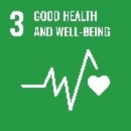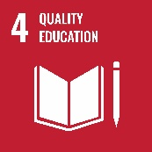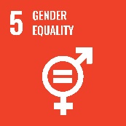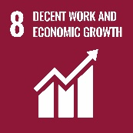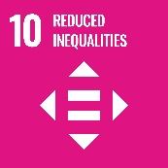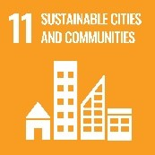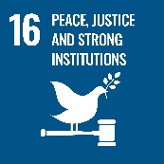
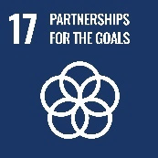

United Nations Disability and Development Report 2018
The United Nations Disability and Development Report 2018 investigated the relationship between disability and the achievement of the SDGs. It found that people with disability are more disadvantaged in terms of the achievement of the SDGs because of barriers they experience living in society.
The report identifies the following barriers for people with disability:
- Lack of accessibility in physical and virtual environments
- Negative attitudes
- Stigma and discrimination
- Lack of access to assistive technological and to rehabilitation
Lack of measures to promote the independent living of persons with disabilities.
The report also recognises that some groups in society are more likely to experience discrimination. These include:
- Women with disabilities
- Indigenous people with disabilities
- People with intellectual and physical disabilities.

National

Disability Discrimination Act 1992
The Disability Discrimination Act 1992 (DDA) protects people with disability in Australia from discrimination. It provides the legal definition of disability in Australia and recognises the following types of disability:
- Physical
- Intellectual
- Sensory
- Neurological
- Learning and psychosocial
- Diseases and illnesses
- Physical disfigurement
- Medical conditions
Work related impairments.
The act states it is unlawful for any person or organisation, including council and our staff, to discriminate against a person with disability with regard to education, employment, accommodation, goods and service provision, premises, transport or access to Commonwealth laws and programs. The act recognises disability regardless of whether it is from the past, present, future, and also in situations where it may be assumed.

Australia’s Disability Strategy 2021-2031
Australia’s Disability Strategy 2021-2031 provides the national framework for disability inclusion and influences implementation at the state level. The vision of the strategy is for an “inclusive Australian society that ensures people with disability can fulfill their potential, as equal members of the community”.
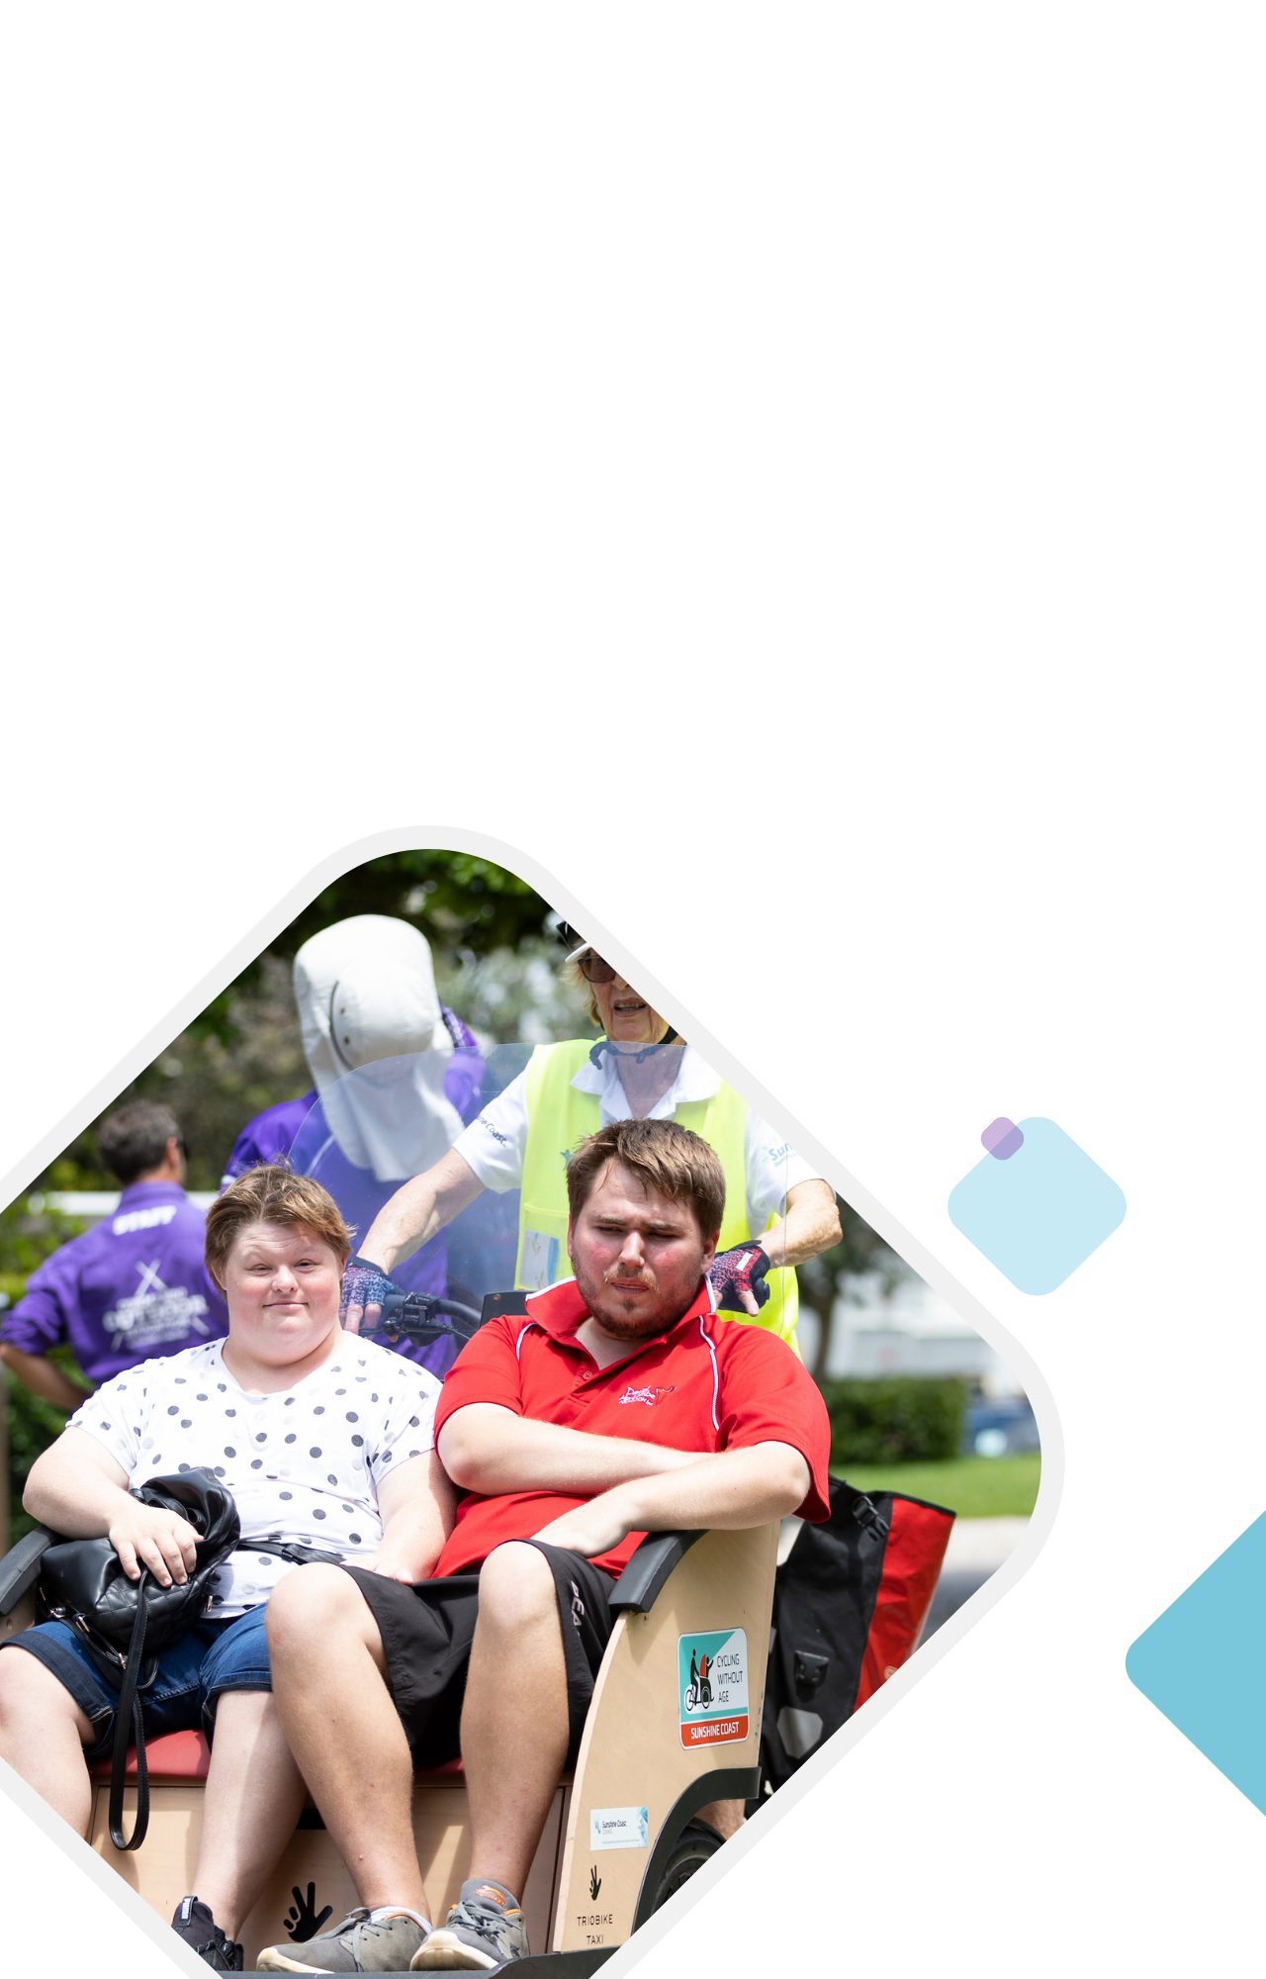
The purpose of the strategy is to provide national leadership towards inclusion of people with disability, influence public policy to be more inclusive and responsive and drive mainstream services and systems to improve outcomes for people with disability.
It calls on all Australians to contribute to an inclusive society where people with disability can fulfil their potential, as equal members of our community.

State

Human Rights Act 2019 (QLD)
The Human Rights Act 2019 protects 23 human rights for Queenslanders including:
- Civil and political rights: such as the right to take part in public life, privacy, peaceful assembly, freedom of movement, and cultural rights
Economic, social and cultural rights: such as the right to education and health services.
The act applies to public entities in Queensland, including local governments, and states that these entities must act and make decisions in a way that is compatible with human rights.

Anti-Discrimination Act 1991 (QLD)
The Anti-Discrimination Act 1991 aims to promote equality of opportunity by protecting the people of Queensland from unfair discrimination. Discrimination is prohibited based on 16 attributes, one of which is disability. The requirements of the act are very similar to the DDA.
Council is required to comply with the act as a service provider.
The act establishes the Anti-Discrimination Commission Queensland which promotes human rights within the community and makes decisions about complaints received under the act.

Disability Services Act 2006 (QLD)
The Disability Services Act 2006 ensures people with disability have choice and influence over access to disability services. It also ensures that services are accountable and suitable to meet the needs of people with disability.
Council is required to comply with the act as a provider of services to the community, including people with disability. This includes:
- Focusing on development of the person with disability and enhancing quality of life
- Providing opportunities for people with disability to be involved in planning and operation of service delivery
Ensuring services are age appropriate, and as would be expected for people within the general community.

Local Government Act 2009 (QLD)
The Local Government Act 2009 outlines the legislative requirements for the operation of local governments in Queensland.
The act includes five principles, one of which relates to democratic representation, social inclusion, and meaningful community engagement.

Communities 2032 Strategy
Communities 2032 is Queensland’s long-term plan that aims to build communities that allow people to live their best lives.
The strategy aims to reach the following ‘destinations’:
- Vibrant, inclusive and cohesive communities
- Healthy, accessible and liveable communities
- Safe and resilient communities
Supported and responsive communities
Each ‘destination’ is guided by the following principles:
- Equity, access and participation
- Human rights and empowerment
Place-based and community led
Communities 2032 is an aspirational plan that sets out a vision for the future of Queensland communities to 2032 and beyond.

Queensland’s Disability Plan 2022-2027
Queensland’s Disability Plan 2022-2027 is the most recent state-wide disability plan. The plan adopts the seven outcome areas in Australia’s Disability Strategy 2021-2031, which are:
- Employment and financial security
- Inclusive homes and communities
- Safety, rights and justice
- Personal and community support
- Education and learning
- Health and wellbeing
- Community attitudes
The plan was prepared through a process of co-design with members of a working group with lived experience of disability.
The plan states the following principles should be considered by all levels of government:
- Co-design
- Measurement of outcomes and impact
- Human rights
Cultural and systems change
In Queensland, local governments are not required to develop a disability service plan, though the state government encourages local governments to develop and/or build on their disability action plans.

Local

Sunshine Coast Community Strategy 2019-2041
The Community Strategy 2019-2041 outlines a long-term vision of how council and the community will work together to achieve a strong community through to 2041. The strategy identifies the following priority areas related to disability inclusion:
2.1. Community infrastructure is safe, welcoming, inclusive, adaptable, well used and activated.
2.3. The public realm supports activated, vibrant places that are green, accessible, inclusive and reflect local character.
3.1. The value all people bring to our community is recognised, respected and embraced.
3.2. Opportunities are available for everyone in our community to participate socially and economically.
3.4. The need for appropriate responses to our community housing are well articulated.
4.6. Efficient and effective transport solutions are delivered with others.
The Sunshine Coast Community Strategy Action Plan 2019-2024 provides more details as to how these priorities can be achieved through multiple actions:
2.1.1. Collaborate and partner to provide increased access to community infrastructure connecting people to information, services and programs.
2.3.1. Collaborate and partner with government and community to identify new opportunities to ensure public spaces are vibrant, activated and accessible places that people enjoy and feel safe.
3.1.2. Collaborate and partner to raise understanding and awareness of the value and opportunities a diverse community brings.
3.2.2. Advocate for a community that is inclusive and accessible for people of all ages and abilities.
3.2.3. Collaborate and partner with government agencies, local business, sport and community organisations to address barriers to participation for members of the community to participate in sport, health and wellbeing, and volunteering opportunities.
3.2.4. Ensure the voices and needs of our community are heard using best practice engagement approaches to inform council action and decision making.
3.4.2. Advocate to community, business and developers on the benefits of universal housing and inclusive design practices.
4.6.1. Collaborate and partner with government, local business and community organisations to provide efficient, accessible transport options that connect people to places.
These eights actions provide direction for initiatives to improve inclusion for people with disability on the Sunshine Coast.

Environment and Liveability Strategy
The Environment and Liveability Strategy 2017 sets out strategic directions to guide the work of council and its partners to ensure a healthy and liveable Sunshine Coast region to 2041. A liveable region should provide opportunity for everyone regardless of age or ability.

Regional Economic Development Strategy
The Regional Economic Development Strategy 2013-2033 provides a 20-year vision and blueprint for sustainable economic growth on the Sunshine Coast. The strategy aims to grow a diverse economy and attract new industries to the region which support higher wages for residents. These priorities may also benefit people with disability by providing more opportunities for employment.

Corporate Plan
Council’s Corporate Plan 2023-27 provides direction for the next five years to advance council’s vision for the Sunshine Coast as Australia’s most sustainable region. All of council’s activities follow-on from the strategic priorities outlined in the Corporate Plan. There is strong alignment with the following strategic priorities and the actions in the Corporate Plan including:
Strategic pathways:
- Vibrant community places and spaces that are inclusive, accessible and adaptable
Responsive, accessible and well managed assets and infrastructure.
Strategic priorities:
- Adopt a place-based approach so that our public realm is supported by activated, vibrant and accessible places
- Collaborate to improve accessibility and inclusion for people with disability and promote the Sunshine Coast as an accessible destination
- Learn from our interactions with customers to design services that are accessible, inclusive and provide community value
Enhance accessibility of services and information through smart tools and platforms.
Delivery pathway:
- Engage with our customers to design inclusive, contemporary and sustainable community services.

Information Sheet 5:

Benchmarking Analysis
A benchmarking analysis was undertaken comparing disability inclusion action plans in South-East Queensland (SEQ), New South Wales (NSW) and Victoria (VIC).
The benchmarking analysis identified 17 action areas. A matrix of the findings is provided below.
The following actions were focussed upon most frequently amongst the action plans reviewed:
- Public realm (e.g., roads, path and cycle ways, parking, public transport, open space and parks)
- Community facilities
- Community events (council organised)
- Council disability awareness staff training
Council communication and engagement.
The following actions were not included in council’s previous Access and Inclusion Plan 2011-2016:
- Playgrounds
- Support for accessibility in private sector development
- Community events (community organised)
- Accessible sporting events
- Accessible sporting and health and wellbeing programs.

Table 1. Benchmarking analysis of disability access and inclusion plans across LGAs in SEQ, NSW and VIC (QLD)
State | SEQ
Councils | Sunshine Coast Council | City of Gold Coast | Logan City Council | Redlands City Council | Moreton Bay Regional Council | Toowoomba Regional Council | Brisbane City Council
Action areas
Public realm
Playgrounds
Public toilets/amenities
Community facilities
Universal Housing Design
Support for accessibility in private sector development
Community events (Council organised)
Community events (community organised)
Council employment and recruitment of persons with disability
Advocacy of employment/volunteering opportunities for people with disability in the private sector
Council supports organisations that employ people with disability
Council disability awareness staff training
Public disability awareness programs/initiatives
Council communication and engagement
Access and inclusion advisory group
Accessible sporting events
Accessible sporting, and health and wellbeing programs

Table 2. Benchmarking analysis of disability access and inclusion plans across LGAs in SEQ, NSW and VIC (NSW)
State | NSW
Councils | City of Sydney | Wollongong City Council | Central Coast Council | Lake Macquarie City Council | Bayside Council
Action areas
Public realm
Playgrounds
Public toilets/amenities
Community facilities
Universal Housing Design
Support for accessibility in private sector development
Community events (Council organised)
Community events (community organised)
Council employment and recruitment of persons with disability
Advocacy of employment/volunteering opportunities for people with disability in the private sector
Council supports organisations that employ people with disability
Council disability awareness staff training
Public disability awareness programs/initiatives
Council communication and engagement
Access and inclusion advisory group
Accessible sporting events
Accessible sporting, and health and wellbeing programs

Table 3. Benchmarking analysis of disability access and inclusion plans across LGAs in SEQ, NSW and VIC (VIC)
State | VIC
Councils | Geelong Council | Mornington Peninsular Council | City of Bayside | City of Melbourne | City of Stonnington
Action areas
Public realm
Playgrounds
Public toilets/amenities
Community facilities
Universal Housing Design
Support for accessibility in private sector development
Community events (Council organised)
Community events (community organised)
Council employment and recruitment of persons with disability
Advocacy of employment/volunteering opportunities for people with disability in the private sector
Council supports organisations that employ people with disability
Council disability awareness staff training
Public disability awareness programs/initiatives
Council communication and engagement
Access and inclusion advisory group
Accessible sporting events
Accessible sporting, and health and wellbeing programs

Sources

United Nations 2006, United Nations Convention on the Rights of Persons with Disabilities, https://www.un.org/development/desa/disabilities/convention-on-the-rights-of-persons-with-disabilities.html
ABS 2019, Disability, Ageing and Carers, Australia: Summary of Findings, https://www.abs.gov.au/statistics/health/disability/disability-ageing-and-carers-australia-summary-findings/2018
WHO 2022, Disability, https://www.who.int/health-topics/disability
University of Sydney 2021, Invisible disabilities: they are more common than you think, https://www.sydney.edu.au/study/why-choose-sydney/student-life/student-news/2021/09/14/invisible-disabilities--they-are-more-common-than-you-think.html
ABS 2019, Disability, Ageing and Carers, Australia: Summary of Findings, https://www.abs.gov.au/statistics/health/disability/disability-ageing-and-carers-australia-summary-findings/2018
ABS 2016, Disability, Ageing and Carers, Australia: Summary of Findings, 2015, https://www.abs.gov.au/AUSSTATS/abs@.nsf/Lookup/4430.0Main+Features12015
Australian Institute of Health and Welfare 2022, People with disability in Australia, https://www.aihw.gov.au/reports/disability/people-with-disability-in-australia
‘Severe disability’ based on responses to need to assistance questions in the Census and does not fully correspond to the ‘profound and severe disability’ category used in the Disability, Ageing and Carers Survey.
ABS 2022, Census 2021, https://www.abs.gov.au/census

